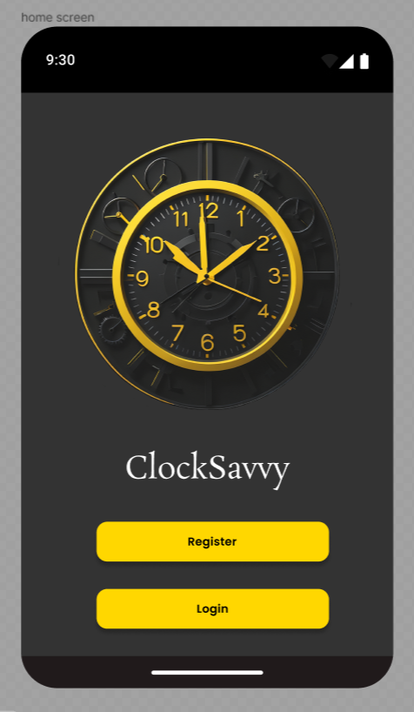

Home Page

This is the first screen upon opening the application. It acts as a home/welcome page displaying the name of our application ‘ClockSavvy’ and our logo.

There are two options available “Register” and “Login”

Each button will take the user to the desired page such as for new users, to the registration page where they will be able to create an account and the login page for returning users to fill in their credentials and sign in.

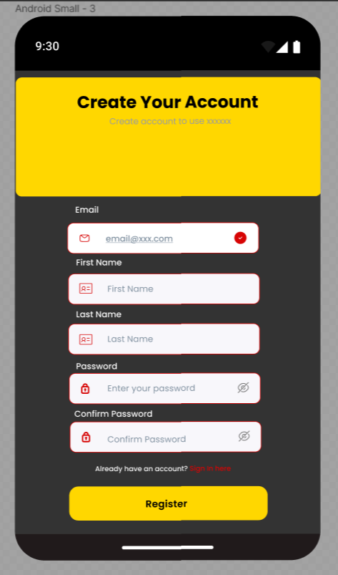

Registration Screen

This is where new users will be able to create an account. The user will enter in their details securely such as their email and password which will be used to login to their account each time they choose to use our application.

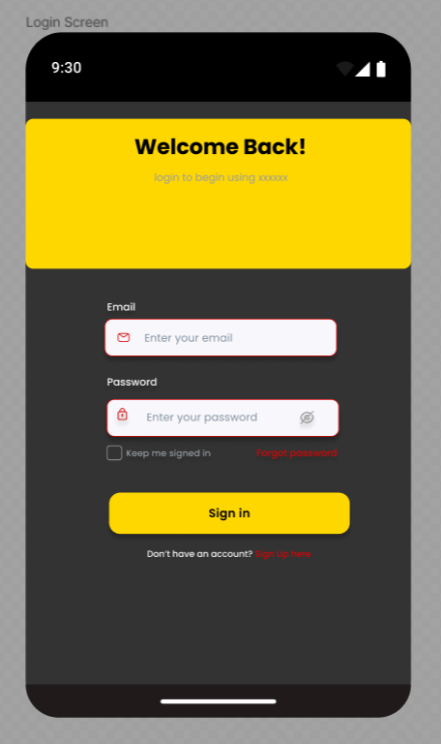

Login Screen

Allows users to log into their account, this is after they have been to the registration page and created an account alternatively for returning users this screen can be accessed directly from the home screen. This is a secure login only for registered users and will allow them to begin using the application.

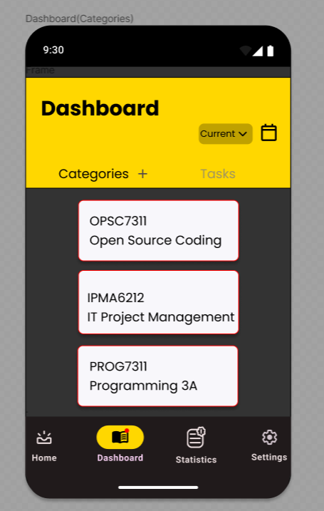

Dashboard(Categories)

The dashboard has 2 screens the user can select ‘Categories’ and ‘Tasks’ which will display each. There is a drop down which will filter the display ‘Current’ will show the current categories. The user will be able to go into each category by tapping on a category which will allow them to view it for editing or deleting. There is a plus icon next to the ‘categories’ text which will task the user to create a category screen allowing users to create new categories.

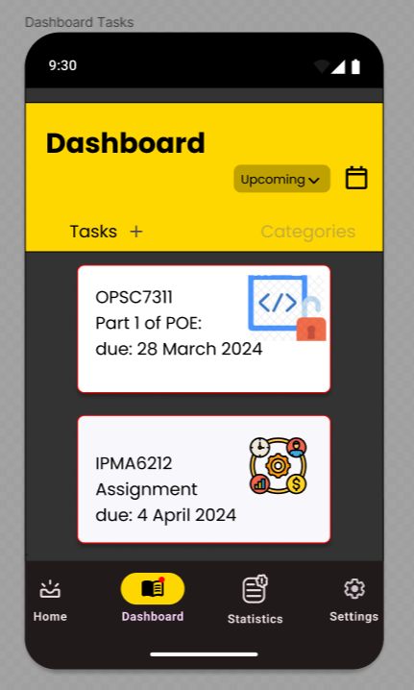

Dashboard(Tasks)

This is the second screen of the dashboard that displays the tasks in the same way as the categories. Users are able to go into each task to edit or delete them. The tasks are also filtered using the drop down in the top left. Like the categories there is also a plus icon next to the ‘Tasks’ text which allows users to go into the create task screen where they are able to create a new task.

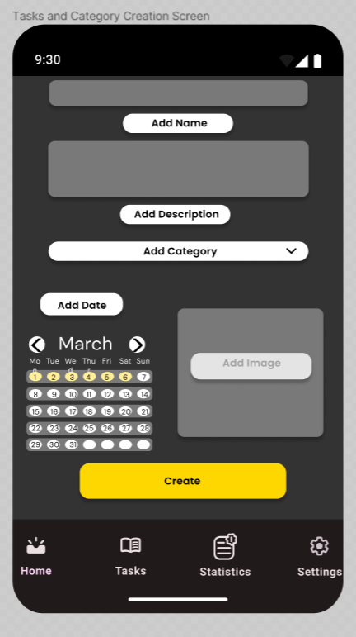

Task and Category Creation Screen

This screen allows users to create a new task by filling in details such as the name and description. The user is also able to choose a category from a drop down that the task is associated with. There is also a calendar on this screen where the user will select the date for the task due date. An image can also be added to the task making it more identifiable on the dashboard. Once the users has completed all of the above they will ‘Create’ the tasks and it will be added into the dashboard. Once the user has successfully created a task they will be redirected to the dashboard.

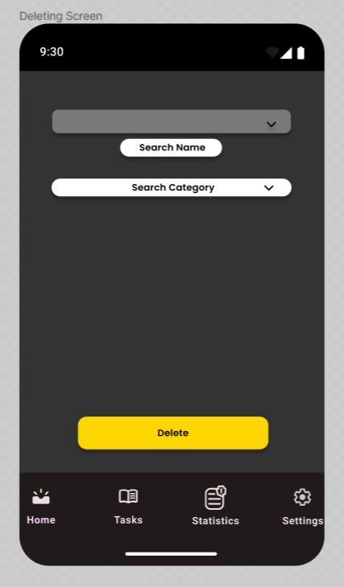

Deleting Screen

Once the user has selected a task they will be able to edit or delete it. This is the delete screen. The user can select the name of the task from the drop down and select the associated category from the drop down as well once they have chosen the relevant task and category they can proceed to delete the task. Once the user has successfully deleted the task they will be redirected to the dashboard.

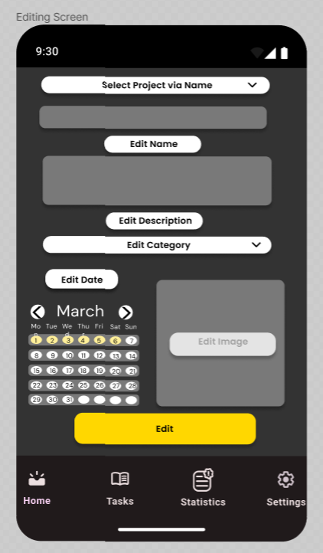

Editing Screen

Once the user selects a task they will be able to edit the details of the tasks including the category. The user can select the project the task is a part of from a drop down, then edit the name of the task, the description of the tasks, the category the task is associated with, the due date and the image that was set to that task. Once all these or only some details have been changed the user will ‘edit’ the task and it will redirect them to the dashboard where they can view the updated task details.

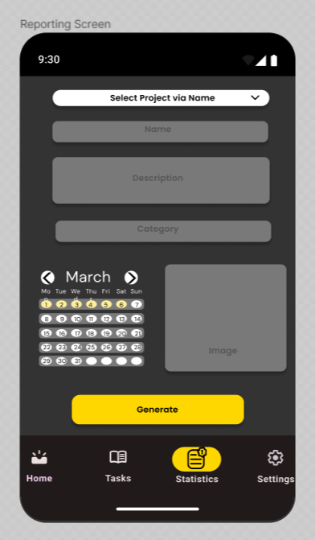

Reporting Screen

The user can access this screen by choosing the statistics icon at the bottom of the screen. On this screen the user will be able to generate a report by choosing or inputting in all the relevant details on the project they wish to generate a report for. Once completed a report will be generate and sent to the user’s email.

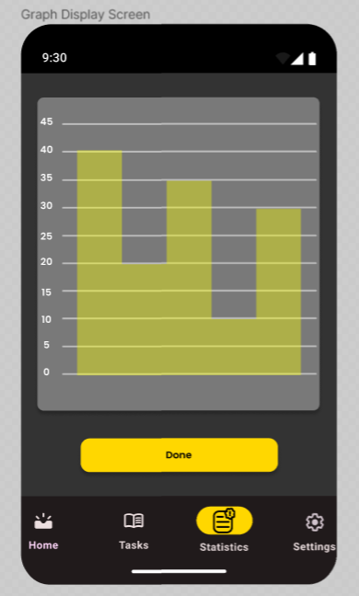

Graph Display Screen

The User is able to view the statistics of time tracked through the graph display at any point by accessing the statistics screen. This will be a detailed graphical display of time spent per task or project daily/weekly/monthl.